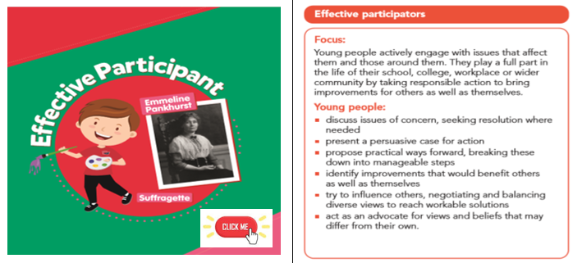
Year 6 Focus – Emmeline Pankhurst

Today, Year 6 will be focusing on Emmeline Pankhurst (15 July 1858 – 14 June 1928). Emmeline was the leader of the British suffragette movement which helped women win the right to vote. In 1999, Time Magazine named her as one of the 100 Most Important People of the 20th Century, stating: "she shaped an idea of women for our time; she shook society into a new pattern from which there could be no going back." She was widely criticized for her militant tactics, but her work helped to achieve women's suffrage in Britain.

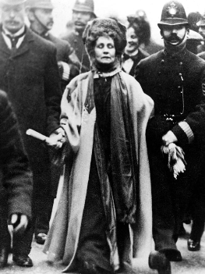
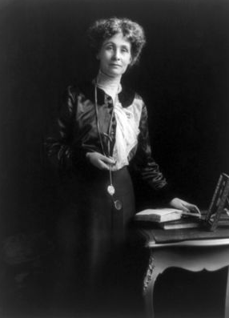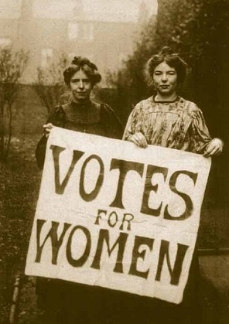
Remember to press Ctrl and click on any underlined words or images to find out more information.
Below are three activities we would like you to complete across today.
The most creative work from each year group will be displayed on the whole school dojo page so that everyone in the school can view it!
Task 1
Research and document Emmeline Pankhust’s key life events as a time line and then write a biography about her. Think back to when we wrote biographies about Ussain Bolt and Malala Yousafzai. Your final – published pieces on the ipads were amaing! How did you structure your biography? Did you use technical or subject-specific vocabulary? What puncuation did you use? Could you make this one – your third attempt at a Biography – even better?
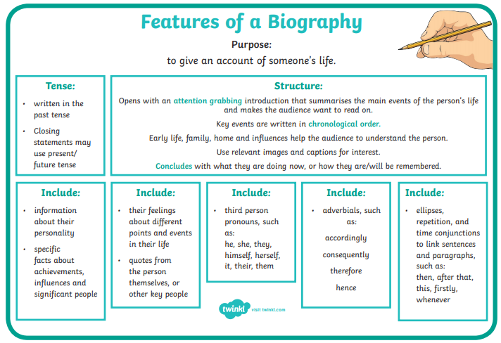

Task 2
Create a banner for something you believe should be changed in the world and then write a speech to go with your banner; persuading the governement to make the change you want.
Remember to address your reader - allow them to feel how passionate you are about the change. Could you include rhetorical question? Modal verbs? Emotive Language. You may want to use this ‘PEEL’ stratergy below to structure your speech –
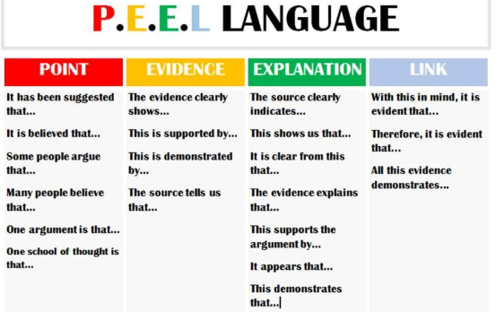

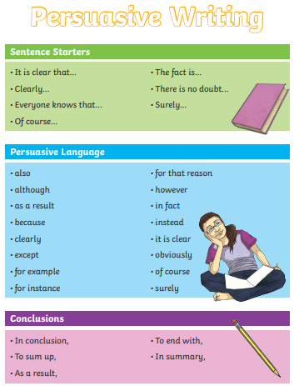
Remember to be persuasive –

Task 3
Design a memorial plaque for Emmeline Pankhurst. Memorial plaques are a long-lasting way to commemorate a person after they pass away. They are plates of metal or stone that are attached to a fixture - to honour the life of the deceased. They will typically have inscriptions including the name of the person, key details of their life and a personal statement or sentimental words which highlight the deceased’s character.
Think about:
Who is the memorial for?
Where would it be located?
Why is this person celebrated?
What key characteristics did this person exhibit?
What will the plaque look like?
